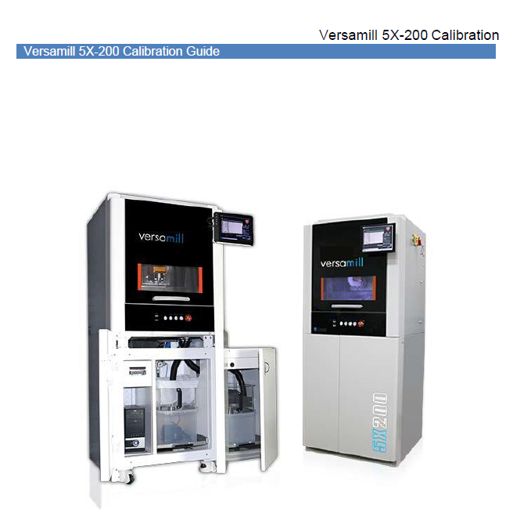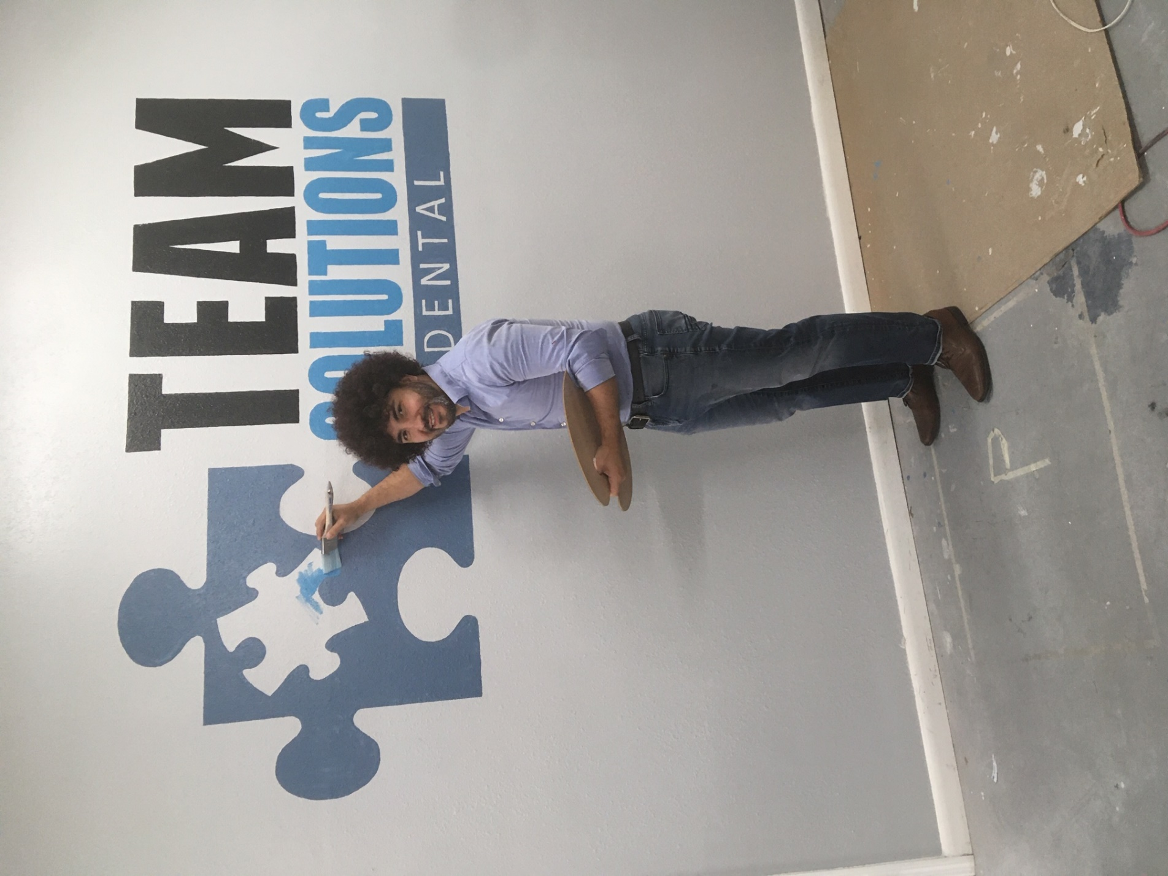

Versamill 5X200 Revised Calibration Process

Versamill 5X-200 Calibration

Introduction

The purpose of the calibration routines is to align the programmed part zero to the centerline of both rotary axes. This procedure is typically required if the machine has been subject to some sort of machine collision, electrical power issue or deletion of current calibration data. If you notice your machined units are too thick or too thin or there is a noticeable shift in geometry between the top and the bottom, then a machine calibration is necessary. Aside from something catastrophic occurring, it is always a good idea to re-calibrate the equipment about every 6 months to ensure that you’re getting the high possible quality out of your 5X-200 mill.

There are 3 programs that are executed to calibrate the machine.

It should be noted that – per Versamill support – a Y calibration or a Z-B calibration can be performed on its own and it will not negatively impact the adjustment program’s execution. Please see instructions on this specific process in the body of this work.

Y-CALIBRATION.NC – This program determines the center of rotation for the A axis.

It machines the part in the Y axis from both sides (A0 and A180) To determine the Y offset.

Z-B-CALIBRATIPON.NC – This program determines the B and Z offsets by cutting to a known dimension in the Z axis on both sides of the part

CALIBRATION-ADJUSTMENT.NC – This program is used to make the adjustments to the offsets based upon the calibration measurements entered into this program. All calculations and register updates are performed automatically.

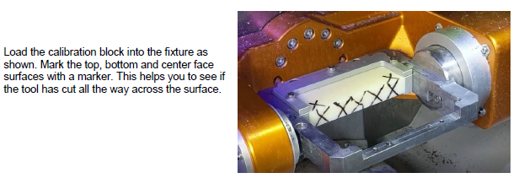

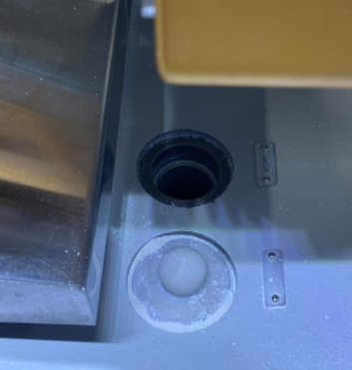Important note!!!!!

**The Versamill calibration process runs as if the machine were**

**milling metal. Please move the drain plug to the appropriate**

**location to prevent cross contamination of the coolant tanks.**

You will need to attach a usb keyboard to the controller of the mill to be able to change values on the .nc files. Transfer the three previously mentioned files to the mill to be calibrated via network folder or thumb drive. It is also recommended that a tablet or laptop be used to keep these instructions close to you during the calibration process.

Calibrating the Y Axis (A axis centerline)

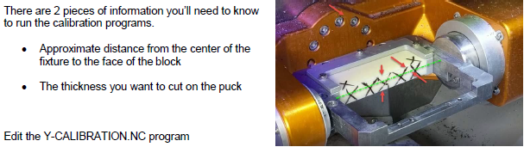

The program looks like this when opened in notepad on the controller:

; Y-AXIS CALIBRATION

; ENTER THE PUCK THICKNESS INTO #1

; ENTER THE Y POSITION YOU WANT TO CUT - TOOL DIAMTER IS ACCOUNTED FOR

#1=16.2 ; PUCK THICKNESS

#2=8.5; Y DISTANCE FROM CENTER

*This is the number that you will adjust the most. If you are using a used cal block, having the value used on the previous calibration makes the process faster. As always you should sacrifice speed to avoid crashes.*

First, set the Value for #1 to the desired thickness you want to cut. This value should be about .2mm less than its current thickness. Set #2 to the distance from Centerline you want to cut. For a new short block, this value should be around 8.0. Save the program and open it in the control to run.

The tool will cut halfway down at the A0 position and then other half from the A180 position. Make sure the cut has removed the material all the way across the face. If not, then adjust #2 to cut a little deeper.

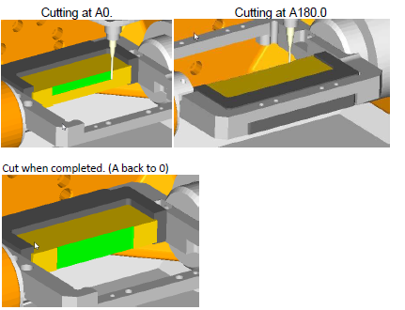

Calibrating the Z and B Axis

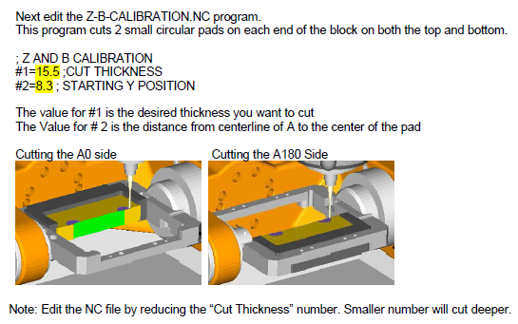

You should only need to change #1 unless your block is very used. Then it is advisable to increase #2 to move the circles on the cal block toward the back of the mill.

Measurements

Upon completion of the cuts, you must measure and enter measurements into the calibration adjustment file.

Measuring the Y Axis

For the Y axis measurement, you must use a dial indicator. The one provided is most likely a 0.0005 dial indicator. These indicators are in inches and the program converts it into metrics for us. Please calculate and enter the values by following the instructions below:

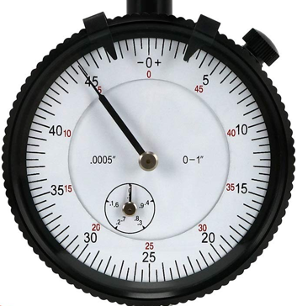

1. **Reading on the inner dial:** Imagine that the needle stops at number 0.2. Then, simply the reading of the inner dial is 0.2 inches. If you find it stop at the mark between 0.2 and 0.3, then it is 0.25 inches. In this case, we choose reading 0.2 for easier calculation.
2. **Reading on the outer dial**: In the meantime, of the smaller needle is stopping at number 0.2 on the smaller scale, the bigger needle is stopping at number 15 on the bigger scale. Because there are 30 divisions (2 x 15) that is passed, it means 30 x 0.0005″ = 0.015″. If this seems confusing just count the marks between the numbers and you will see that there are ten marks between each number and the numbers are all multiples of 5. So, every number must be multiplied by 2 and then by 0.0005 to get the actual measurement in inches.
3. **Calculation**: Now, let’s add them to get the final result. The total travel distance is the addition of inner reading and outer dial reading. In number, 0.2″+ 0.015″ = 0.215″.

*Inner Reading + Outer Reading = Total Reading*

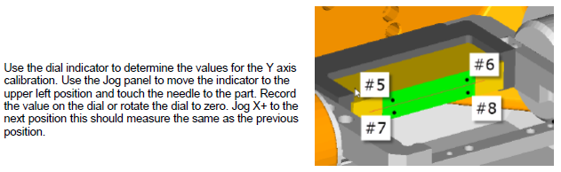

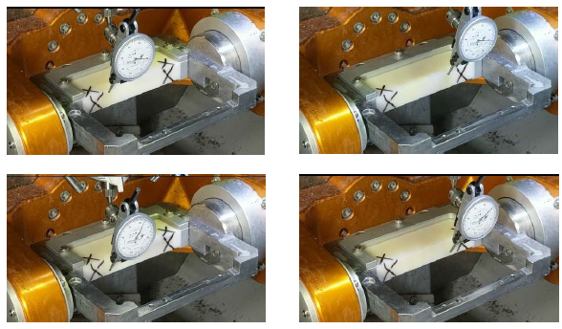

When reading the indicator in this position the needle moved in the **counterclockwise** direction from the 0 mark. This indicates a **positive value**. Please be aware that incorrectly entering positive or negative values will negatively impact your calibration.

Measuring the Z and B Axis

Use the digital micrometers to measure the thickness at the left and right circular pads.

Make sure the micrometers are set to mm.

This will determine the values need to set the Z and B work offsets. 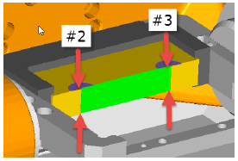

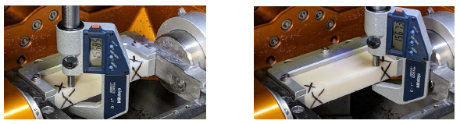

Adjusting the work offsets

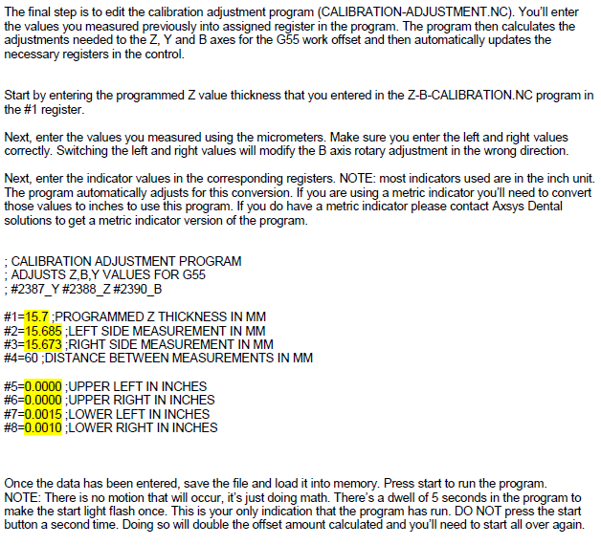

It must be stressed that this process requires time to complete. Do not allow distractions to interfere with the process once started and be sure to perform a cube test and test crown upon completion to help verify proper calibration. If you have any questions during the process, stop and seek the answers from tech support.